[hiteshharish06@gmail.com](mailto:hiteshharish06@gmail.com)

**Screenshots**

**1.Resource Group Overview:**

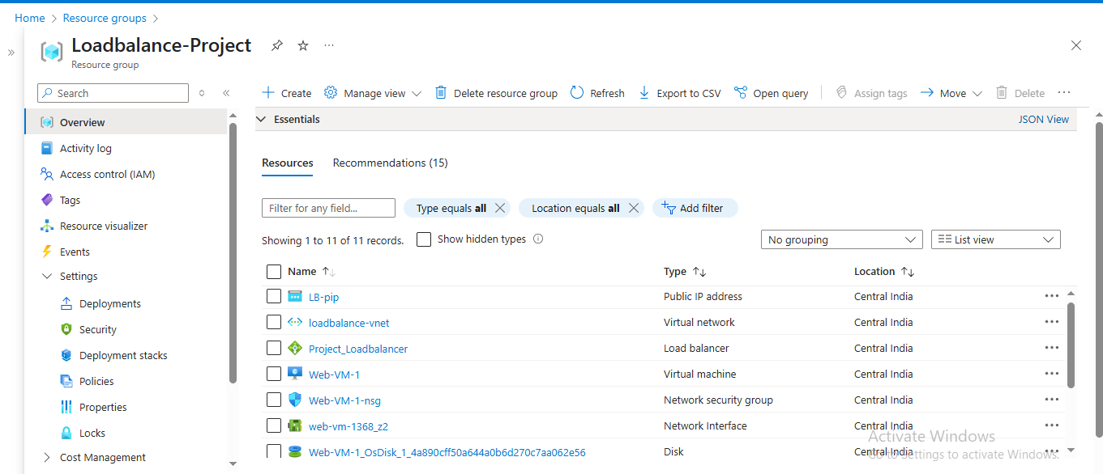

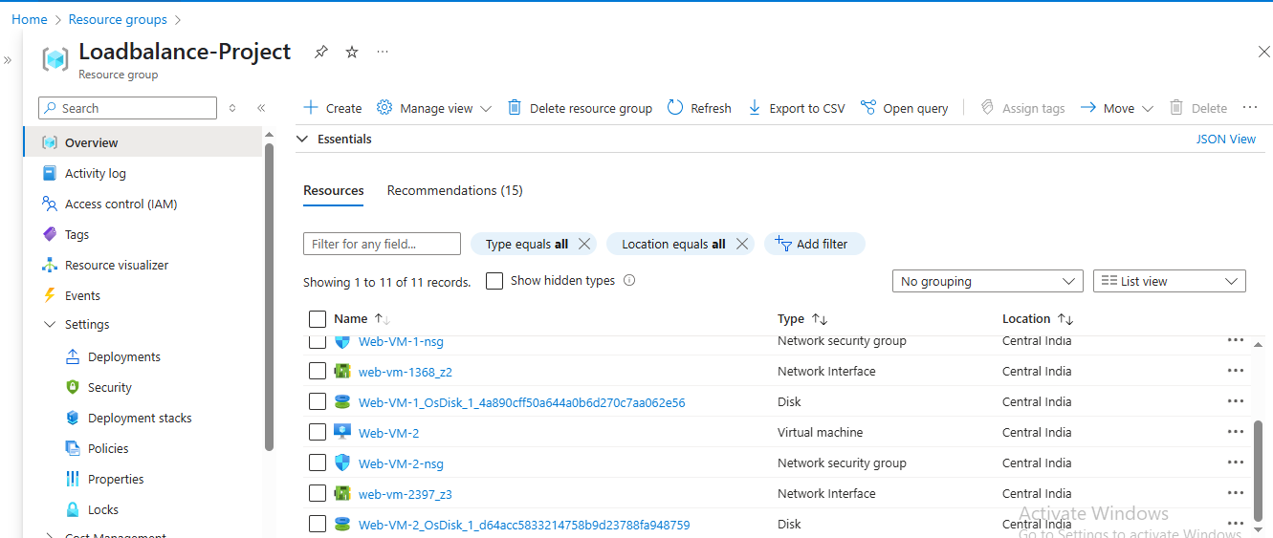

**2.Load Balancer Configuration:**

**a.Frontend IP Configuration:**

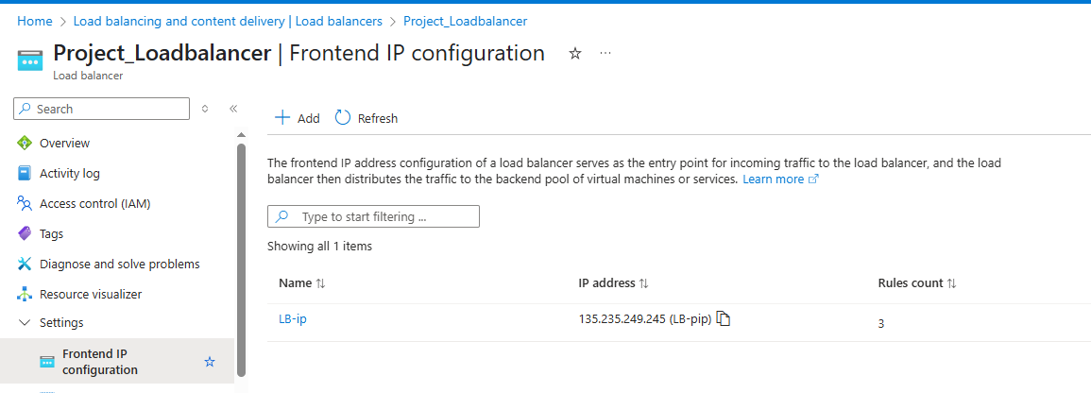

**b.Backend Pools:**

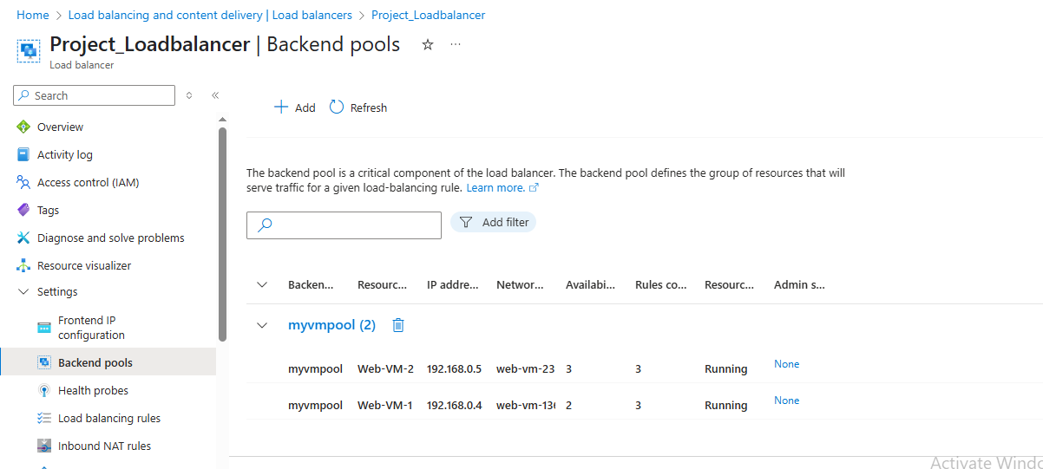

**c.Health Probes:**

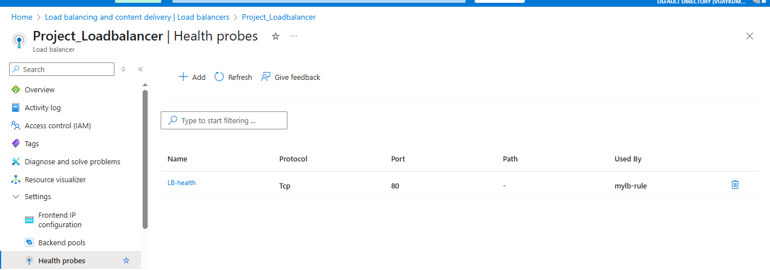

**d. Load Balancing Health Rules:**

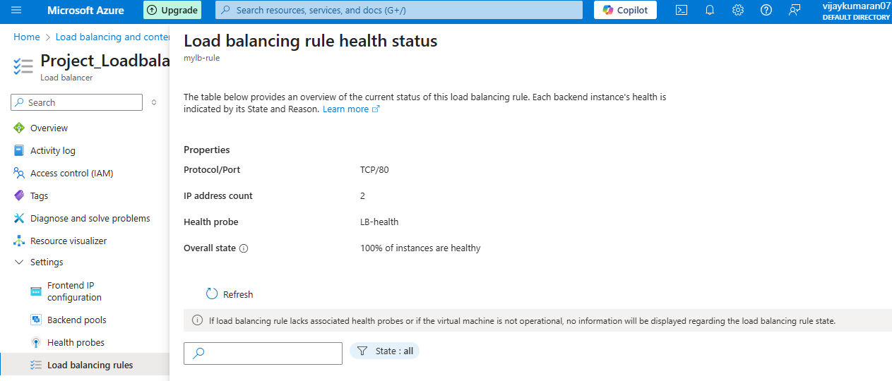

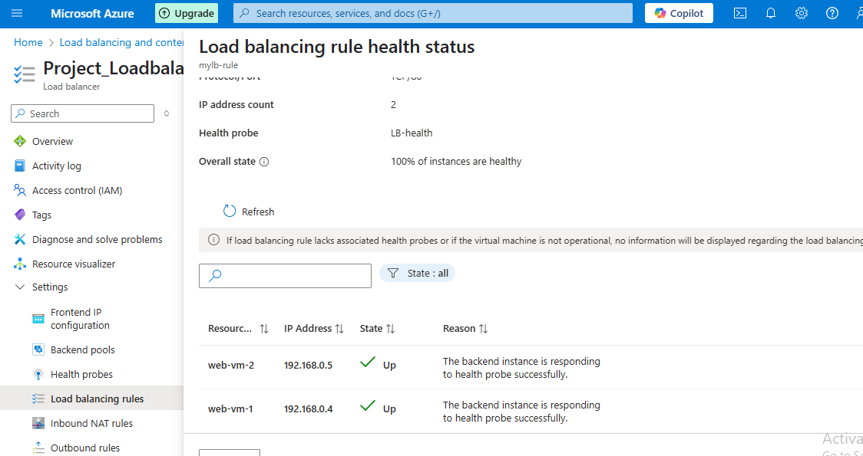

**e. Inbound NAT Rule:**

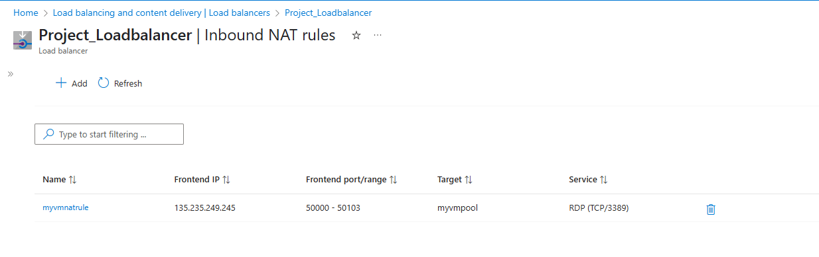

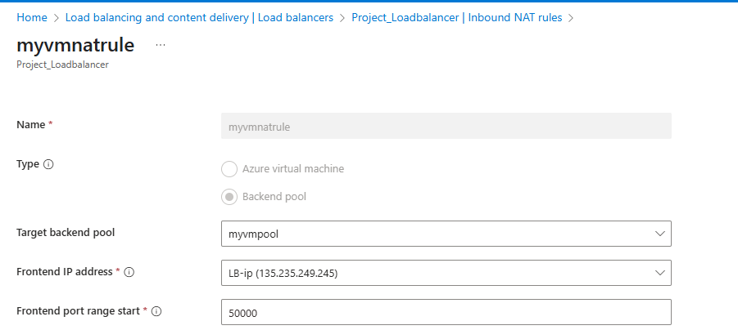

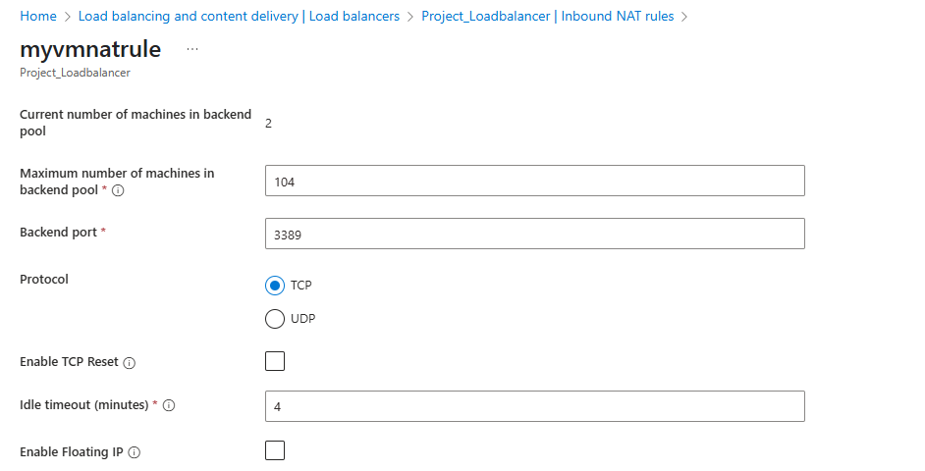

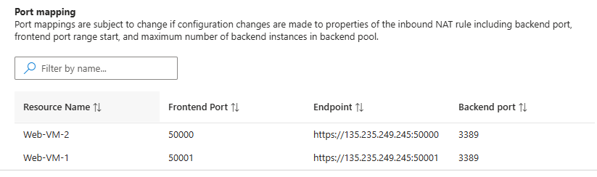

**f.Outbound NAT Rule:**

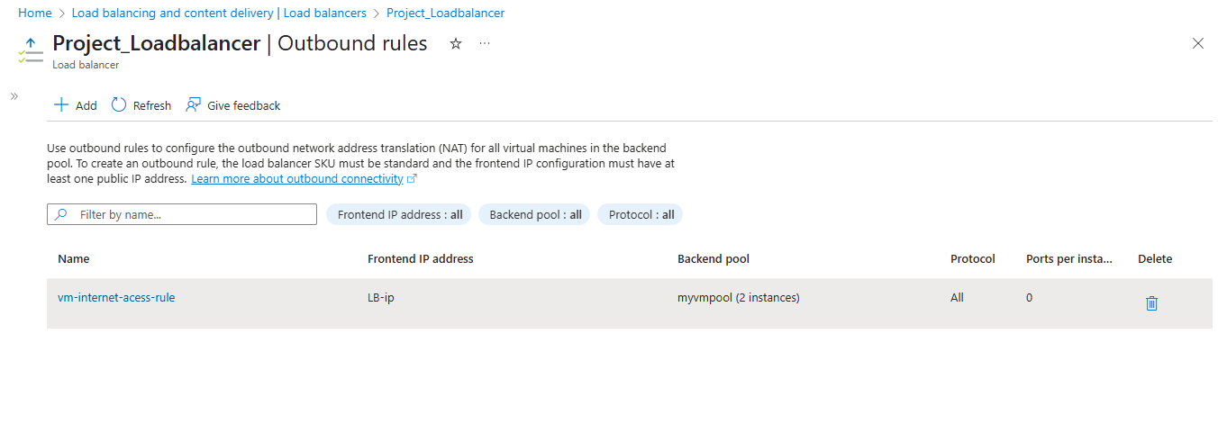

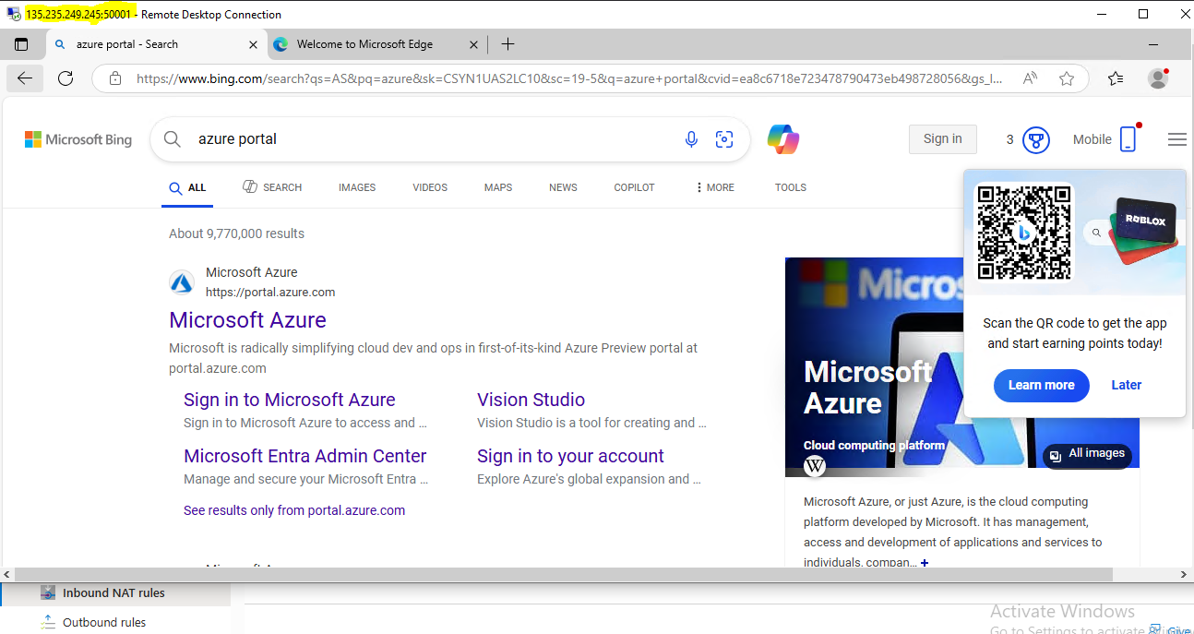

**3.Virtual Machine:**

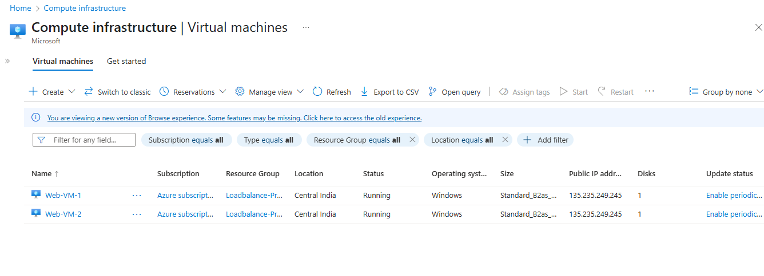

**a.Virtual machine 1(overview):**

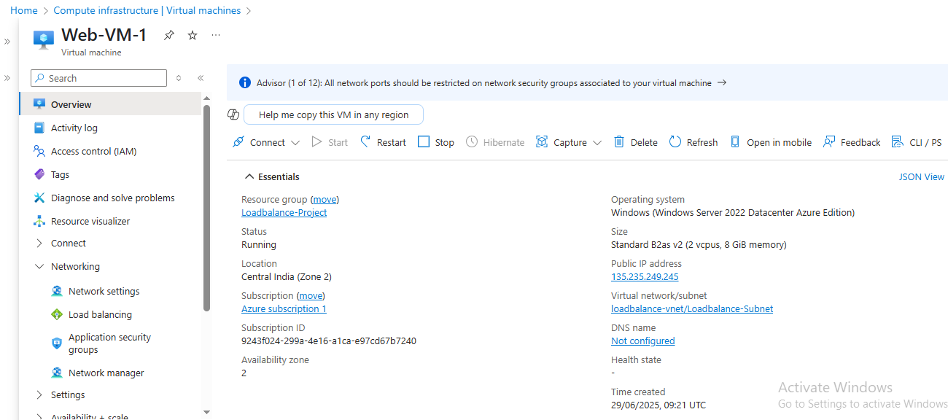

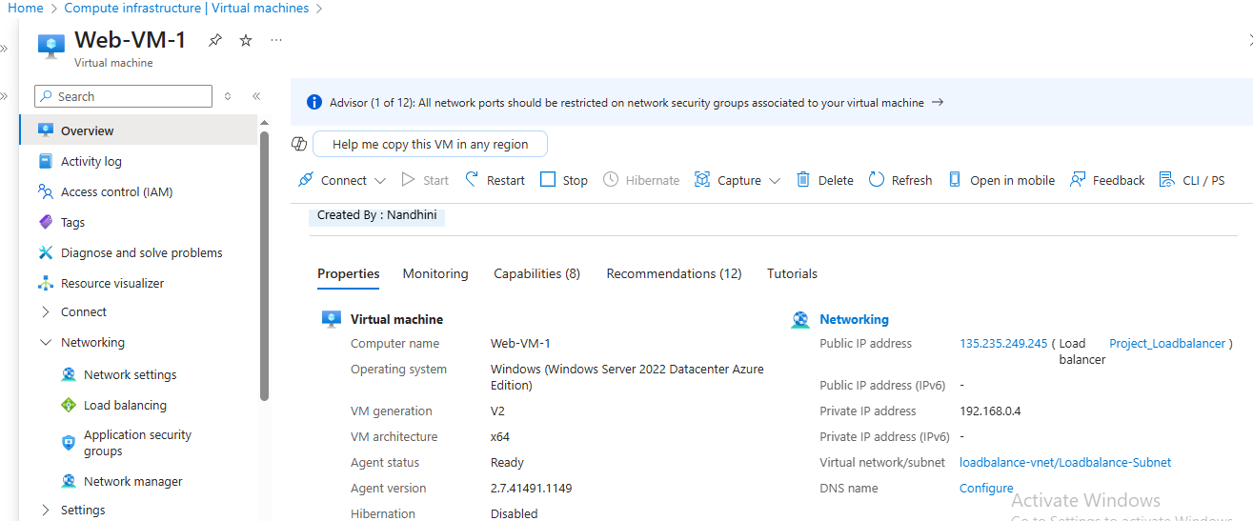

**b. Virtual machine 2(overview):**

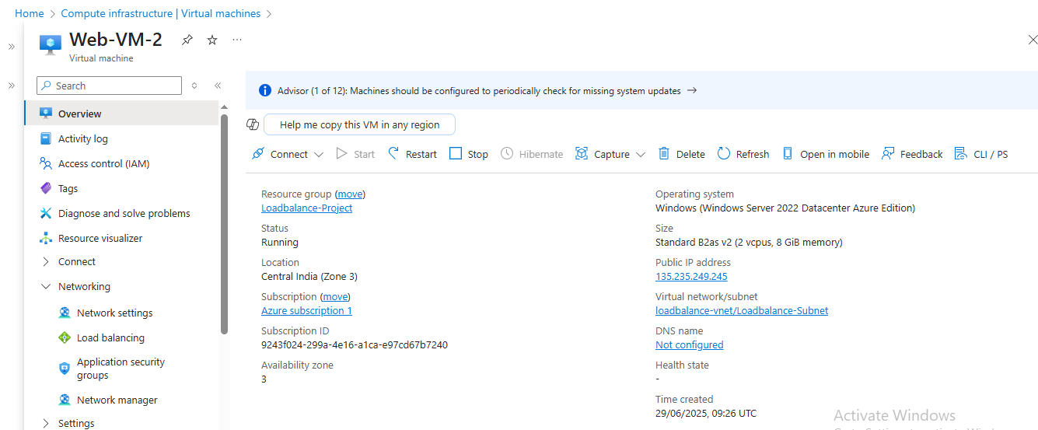

**4.Network Security group:**

**a.Inbound Rules For vm1:**

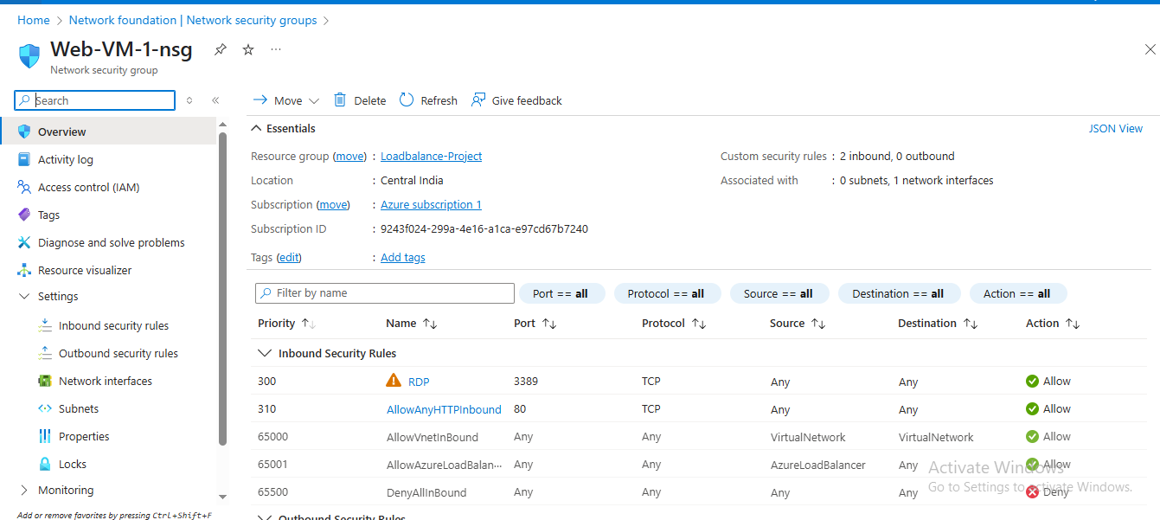

**b. Inbound Rules For vm2:**

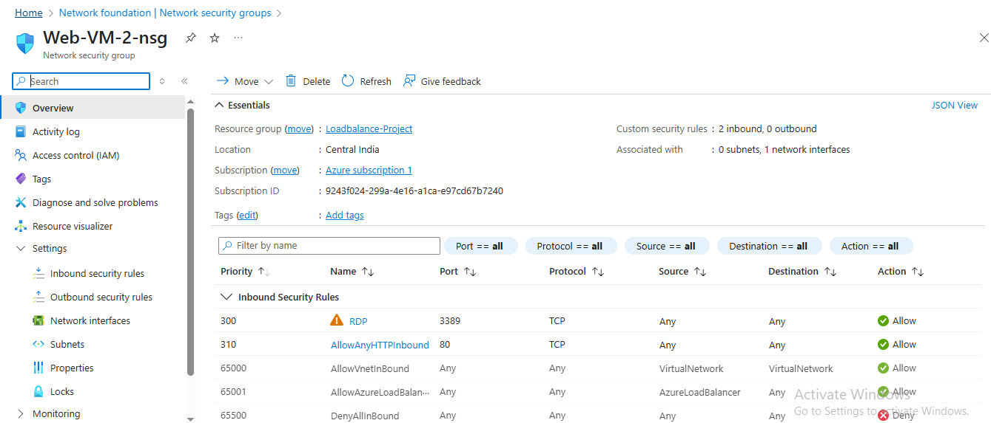

**5.Testing Result:**

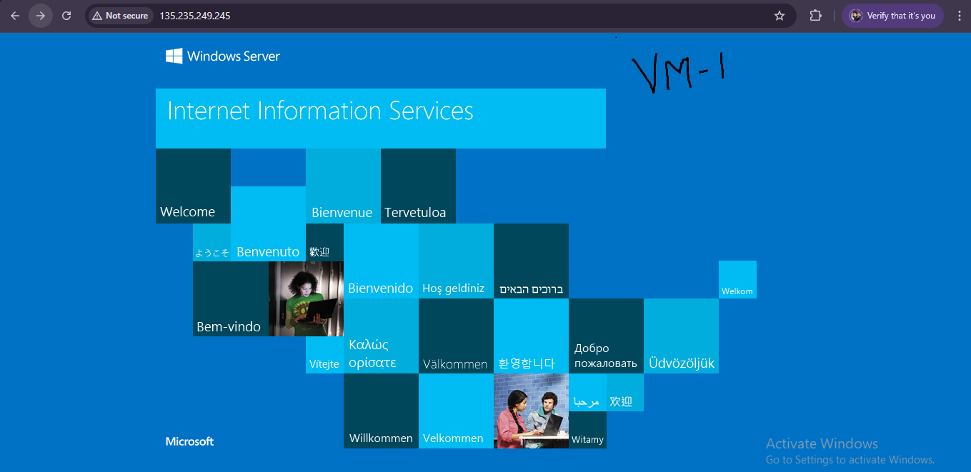

**After Hard Refresh :**

